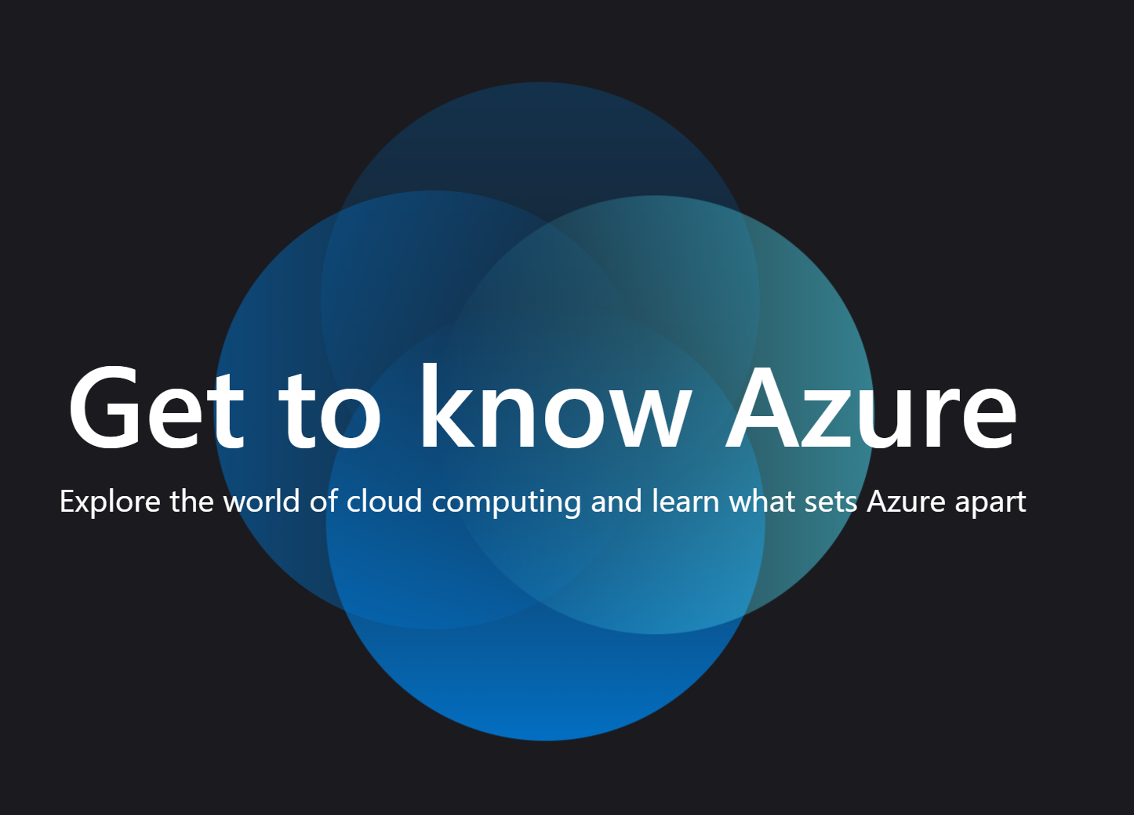

**Azure Developer Series**

**Migrating a dotnetcore 2-tier application to Azure,  
using different architectures and DevOps best practices**

Hands-On-Labs step-by-step guides

Prepared by:

**Peter De Tender**

**CEO and Lead Technical Trainer  
PDTIT and 007FFFLearning.com**

**@pdtit @007FFFLearning**

Version: Sept 2019 – 1.0

Information in this document, including URL and other Internet Web site references, is subject to change without notice. Unless otherwise noted, the example companies, organizations, products, domain names, e-mail addresses, logos, people, places, and events depicted herein are fictitious, and no association with any real company, organization, product, domain name, e-mail address, logo, person, place or event is intended or should be inferred. Complying with all applicable copyright laws is the responsibility of the user. Without limiting the rights under copyright, no part of this document may be reproduced, stored in or introduced into a retrieval system, or transmitted in any form or by any means (electronic, mechanical, photocopying, recording, or otherwise), or for any purpose, without the express written permission of Microsoft Corporation.

Microsoft may have patents, patent applications, trademarks, copyrights, or other intellectual property rights covering subject matter in this document. Except as expressly provided in any written license agreement from Microsoft, the furnishing of this document does not give you any license to these patents, trademarks, copyrights, or other intellectual property.

The names of manufacturers, products, or URLs are provided for informational purposes only and Microsoft makes no representations and warranties, either expressed, implied, or statutory, regarding these manufacturers or the use of the products with any Microsoft technologies. The inclusion of a manufacturer or product does not imply endorsement of Microsoft of the manufacturer or product. Links may be provided to third party sites. Such sites are not under the control of Microsoft and Microsoft is not responsible for the contents of any linked site or any link contained in a linked site, or any changes or updates to such sites. Microsoft is not responsible for webcasting or any other form of transmission received from any linked site. Microsoft is providing these links to you only as a convenience, and the inclusion of any link does not imply endorsement of Microsoft of the site or the products contained therein.

© 2019 Microsoft Corporation. All rights reserved.

Microsoft and the trademarks listed at https://www.microsoft.com/en-us/legal/intellectualproperty/Trademarks/Usage/General.aspx   
are trademarks of the Microsoft group of companies. All other trademarks are property of their respective owners.

**Contents**

**Migrating a dotnetcore 2-tiered application to Azure using different architectures and DevOps best practices - Hands-On-Labs step-by-step** Hands-On-Lab Scenario 4

Abstract and Learning Objectives 5

Requirements 6

Naming Conventions: 6

Azure Subscription: 6

Other requirements: 6

Alternative Approach: 6

Final Remarks: 7

Lab 1: Preparing your Hands-On-Lab environment 8

What you will learn 8

Time estimate 8

Task 1: Deploying the lab-jumpVM Virtual Machine using Azure Portal Template deployment 8

Task 2: Deploying the baseline Virtual Machine environment using an ARM-template from within Visual Studio 2017/2019 16

Summary 33

# **Migrating a dotnetcore 2-tiered application to Azure using different architectures and DevOps best practices - Hands-On-Labs step-by-step** Hands-On-Lab Scenario

You are part of an organization that is running a dotnetcore e-commerce platform application, using Windows Server infrastructure on-premises today, comprising a WebVM running Windows Server 2012 R2 with Internet Information Server (IIS) and a 2nd SQLVM running Windows Server 2012 R2 and SQL Server 2014.

The business has approved a migration of this business-critical workload to Azure, and you are nominated as the cloud solution architect for this project. No decision has been made yet on what the final architecture should or will look like. Your first task is building a Proof-of-Concept in your Azure environment, to test out the different architectures possible:

* Infrastructure as a Service (IAAS)
* Platform as a Service (PAAS)
* Containers as a Service (CaaS)

At the same time, your CIO wants to make use of this project to switch from a more traditional mode of operations, with barriers between IT sysadmin teams and Developer teams, to a DevOps way of working. Therefore, you are tasked to explore Azure DevOps and determine where CI/CD Pipelines can assist in optimizing the deployment and running operations of this e-commerce platform, especially when deploying updates to the application.

As you are new to the continuous changes in Azure, you want to make sure this process goes as smooth as possible, starting from the assessment to migration to day-to-day operations.

# Abstract and Learning Objectives

This workshop enables anyone to learn, understand and build a Proof of Concept, in performing a multi-tiered .Net Core web application using Microsoft SQL Server database, platform migration to Azure public cloud, leveraging on different Azure Infrastructure as a Service, Azure Platform as a Service (PaaS) and Azure Container offerings like Azure Container Instance (ACI) and Azure Kubernetes Services (AKS).

After an introductory module on cloud app migration strategies and patterns, students get introduced to the basics of automating Azure resources deployments using Visual Studio and Azure Resource Manager (ARM) templates. Next, attendees learn about the importance of performing proper assessments, and what tools Microsoft offers to help in this migration preparation phase. Once the application has been deployed on Azure Virtual Machines, students learn about Microsoft SQL database migration to SQL Azure PaaS, as well as deploying and migrating web applications to Azure Web Apps.

After these foundational platform components, the workshop will totally focus on the core concepts and advantages of using containers for running business workloads, based on Docker, Azure Container Registry (ACR), Azure Container Instance (ACI) and WebApps for Containers, as well as how to enable container orchestration and cloud-scale using Azure Kubernetes Service (AKS).

In the last part of the workshop, students get introduced to Azure DevOps, the new Microsoft Application Lifecycle environment, helping in building a CI/CD Pipeline to publish workloads using the DevOps principals and concepts, showing the integration with the rest of the already touched on Azure services like Azure Web Apps and Azure Kubernetes Services (AKS), closing the workshop with a module on overall Azure monitoring and operations and what tools Azure has available to assist your IT teams in this challenge.

The focus of the workshop is having a Hands-On-Labs experience, by going through the following exercises and tasks:

* Deploying a 2-tier Azure Virtual Machine (Webserver and SQL database Server) using ARM-template automation with Visual Studio 2019;
* Publishing a .NET Core e-commerce application to an Azure Web Virtual Machine and SQL DB Virtual Machine;
* Performing a proper assessment of the as-is Web and SQL infrastructure using Microsoft Assessment Tools;
* Migrating a SQL 2014 database to Azure SQL PaaS (Lift & Shift);
* Migrating a .NET Core web application to Azure Web Apps (Lift & Shift);
* Containerizing a .NET Core web application using Docker, and pushing to Azure Container Registry (ACR);
* Running Azure Container Instance (ACI) and WebApp for Containers;
* Deploy and run Azure Azure Kubernetes Services (AKS);
* Deploying Azure DevOps and building a CI/CD Pipeline for the subject e-commerce application;
* Managing and Monitoring Azure Kubernetes Services (AKS);

# Requirements

## Naming Conventions:

IMPORTANT: Most Azure resources require unique names. Throughout these steps you will see the word **“[SUFFIX]”** as part of resource names. You should replace this with your initials, guaranteeing those resources get uniquely named.

## Azure Subscription:

Participants need a “pay-as-you-go”, MSDN or other paid Azure subscription

1. In one of the Azure Container Services tasks, you are required to create an Azure AD Service Principal, wich typically requires an Azure subscription owner to log in to create this object. If you don’t have the owner right in your Azure subscription, you could ask another person to execute this step for you.
2. The Azure subscription must allow you to run enough cores, used by the baseline Virtual Machines, but also later on in the tasks when deploying the Azure Container Services, where ACS agent and master machines are getting set up. If you follow the instructions as written out in the lab guide, you need 12 cores.
3. If you run this lab setup in your personal or corporate Azure payable subscription, using the configuration as described in the lab guide, the estimated Azure consumption costs for running the setups during the 2 days of the workshop is $20.

## Other requirements:

Participants need a local client machine, running a recent Operating System, allowing them to:

* browse to <https://portal.azure.com> from a most-recent browser;
* establish a secured Remote Desktop (RDP) session to a lab-jumpVM running Windows Server 2016;

## Alternative Approach:

Where the lab scenario assumes all exercises will be performed from within the lab-jumpVM, (since several tools will be installed on the lab-jumpVM or are already installed by default), participants could also execute (most, if not all…) steps from their local client machine.

The following tools are being used throughout the lab exercises:

* Visual Studio 2017 community edition (updated to latest version); this could also be Visual Studio 2019 community edition - latest version
* Docker for Windows (updated to latest version)
* Azure CLI 2.0 (updated to latest version)
* Kubernetes CLI (updated to latest version)
* SimplCommerce Open Source e-commerce platform example (<http://www.simplcommerce.com>)

Make sure you have these tools installed prior to the workshop, if you are not using the lab-jumpVM. You should also have full administrator rights on your machine to execute certain steps within using these tools.

## Final Remarks:

**VERY IMPORTANT: You should be typing all of the commands as they appear in the guide, except where explicitly stated in this document. Do not try to copy and paste from Word to your command windows or other documents where you are instructed to enter information shown in this document. There can be issues with Copy and Paste from Word or PDF that result in errors, execution of instructions, or creation of file content.**

**IMPORTANT: Most Azure resources require unique names. Throughout these steps you will see the word “[SUFFIX]” as part of resource names. You should replace this with your initials, guaranteeing those resources get uniquely named.**

# Lab 1: Preparing your Hands-On-Lab environment

## What you will learn

In this first lab, you prepare the baseline for executing all hands-on-labs exercises:

* Log on to your Azure subscription;
* Deploy the lab-jumpVM within your Azure subscription;
* Verify and install the required tools to run the lab exercises;
* Deploy the 2-tiered Azure Virtual Machine infrastructure (WebVM and SQLVM);

## Time estimate

This lab is estimated to take **60min**, assuming your Azure subscription is already available.

## Task 1: Deploying the lab-jumpVM Virtual Machine using Azure Portal Template deployment

In this task, you start from deploying the “lab-jumpVM” Virtual Machine in your Azure environment. This machine becomes the starting point for all future exercises, as it has most required tools already installed.

1. Once you are logged on to your Azure subscription, select **Create a Resource**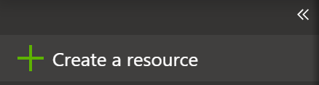
2. In the Search Azure Marketplace field, type “template deployment”  
     
   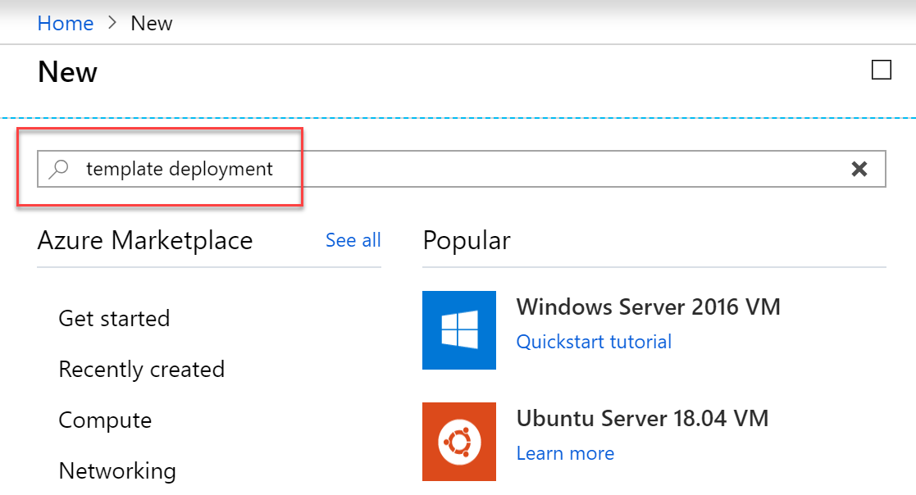
3. And select **template deployment** from the list of MarketPlace results. Followed by clicking the **Create** button down at the bottom.  
     
   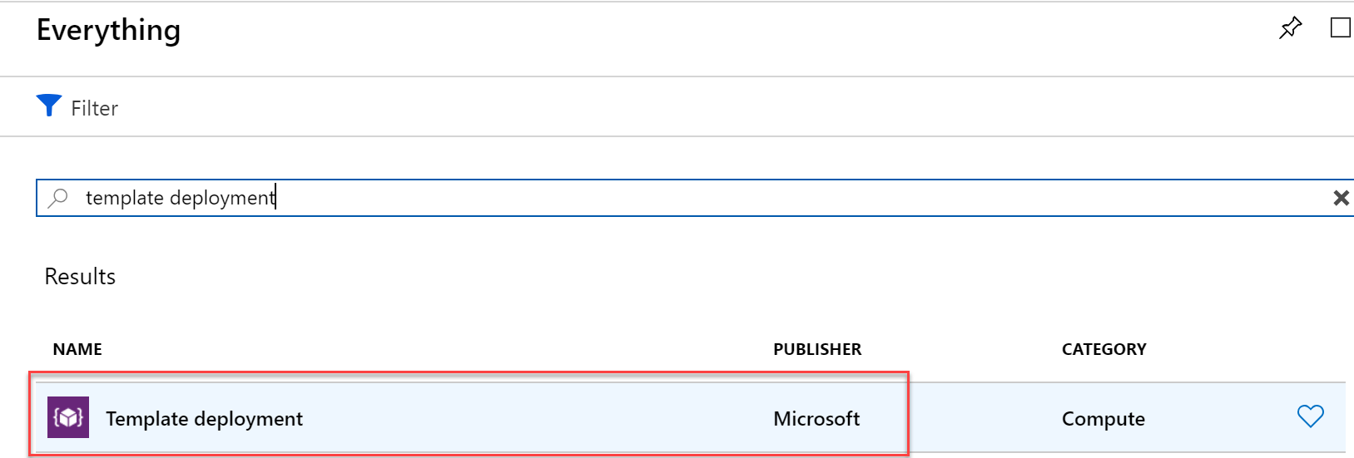
4. This opens the **Custom Deployment** blade. Here, **select** “**build your own template in the editor”**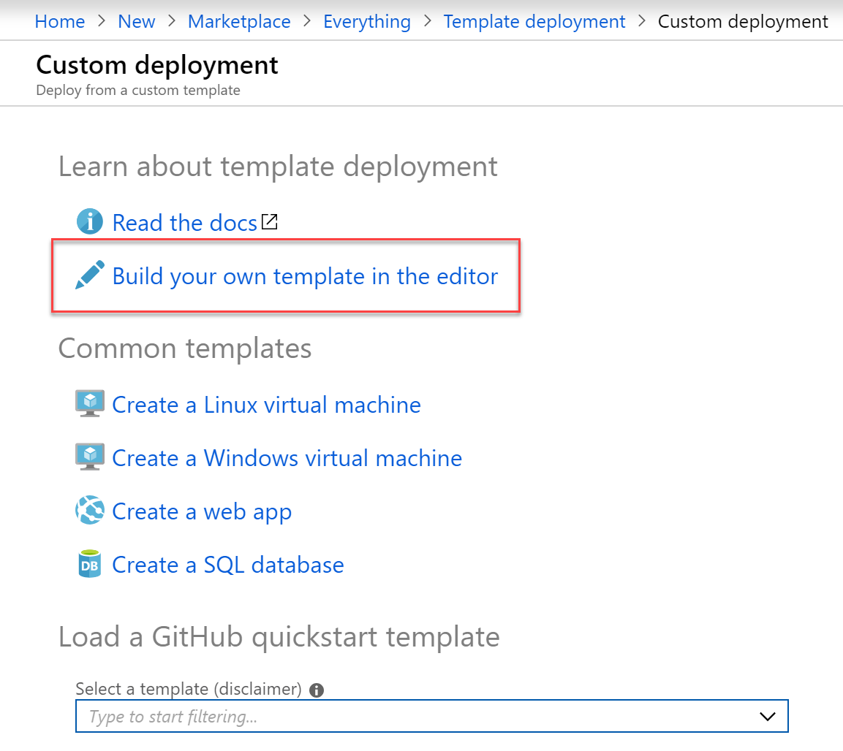
5. First, from a **second tab** in your browser window, go to the following URL on GitHub, browsing the source files repository for this lab, specifically the LabjumpVM folder:  
   <https://github.com/007FFFLearning/ADS-Containers/tree/master/Sources/LabJumpVM>  
     
   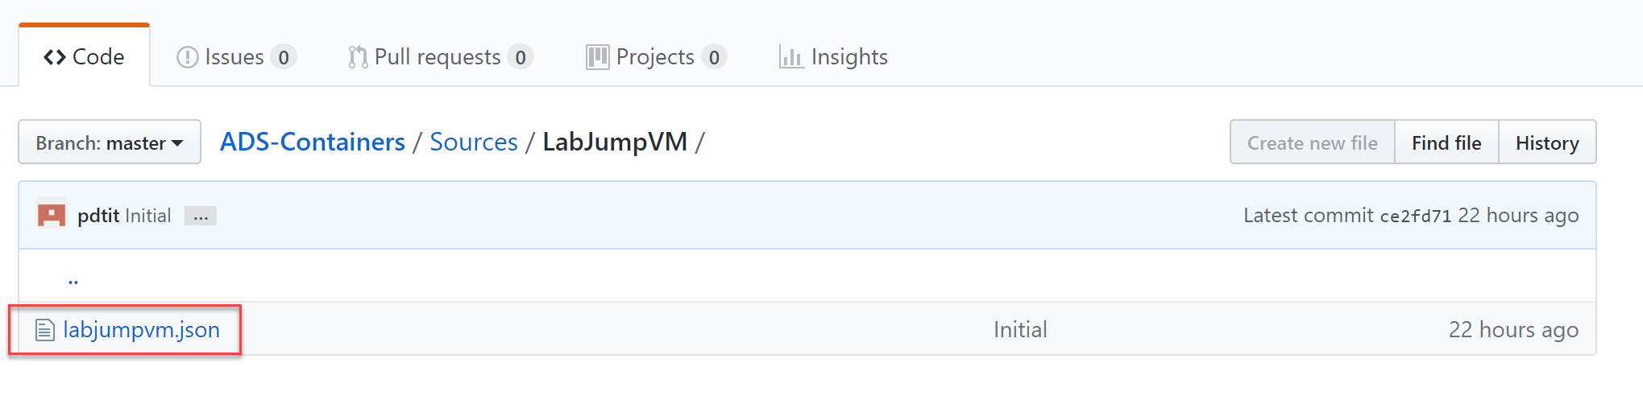
6. **Select** the labjumpvm.json object in there. This exposes the details of the actual JSON deployment file. **Click** the **Raw** button, to open the actual file in your browser.  
     
   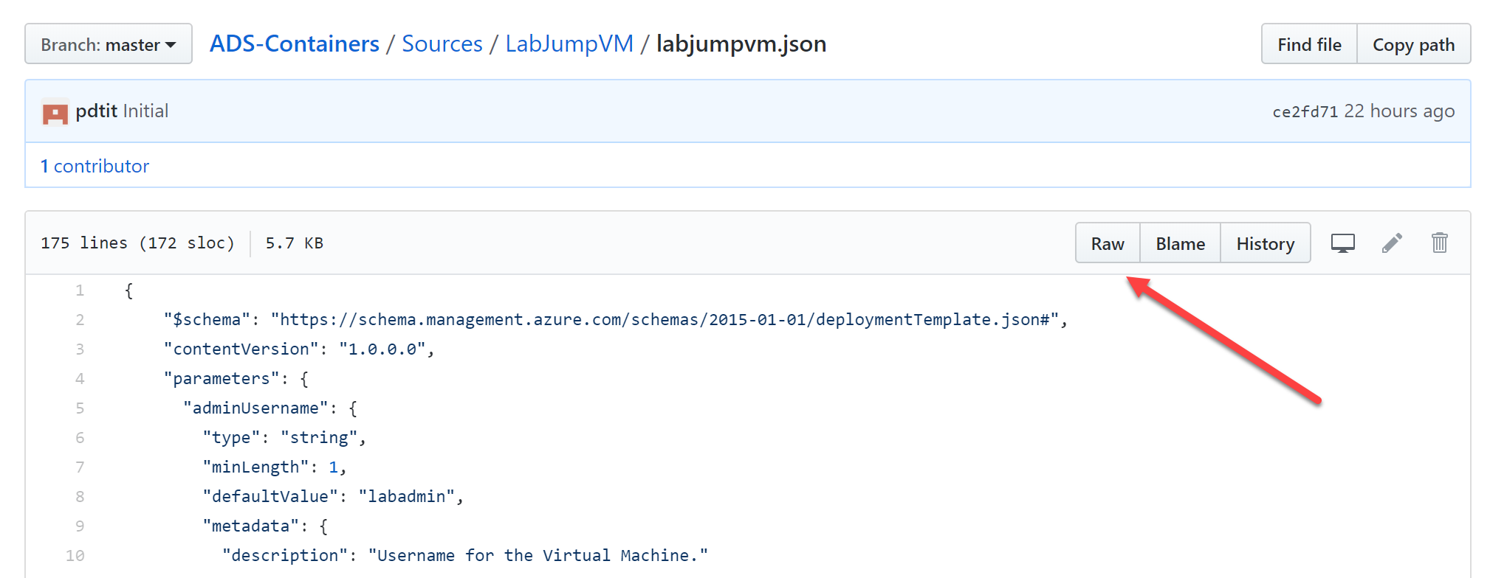
7. Your browser should show the content as follows:  
     
   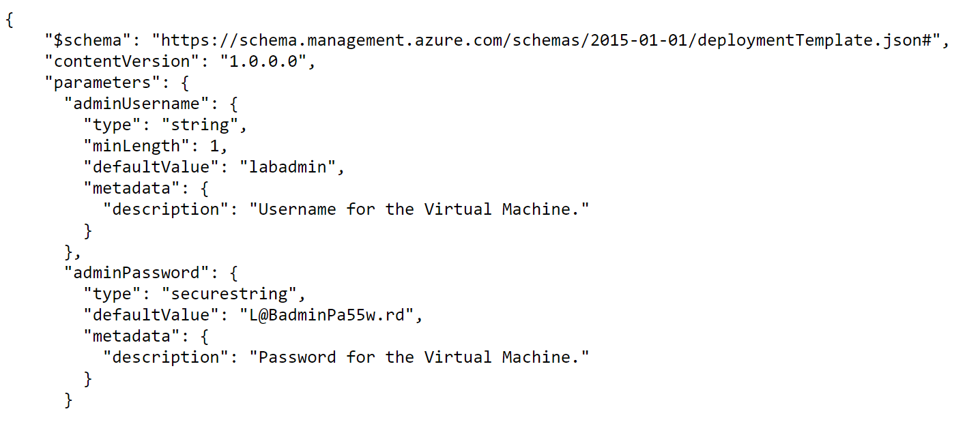
8. Here, use **Ctrl+A** to **select all lines in the JSON** file, and use **Ctrl+C** to copy it to the clipboard.
9. **Go back** to the **Azure Portal**; From the **Edit Template** blade, **remove the first 6 lines of code** you see in there, and **paste in the JSON content from the clipboard.**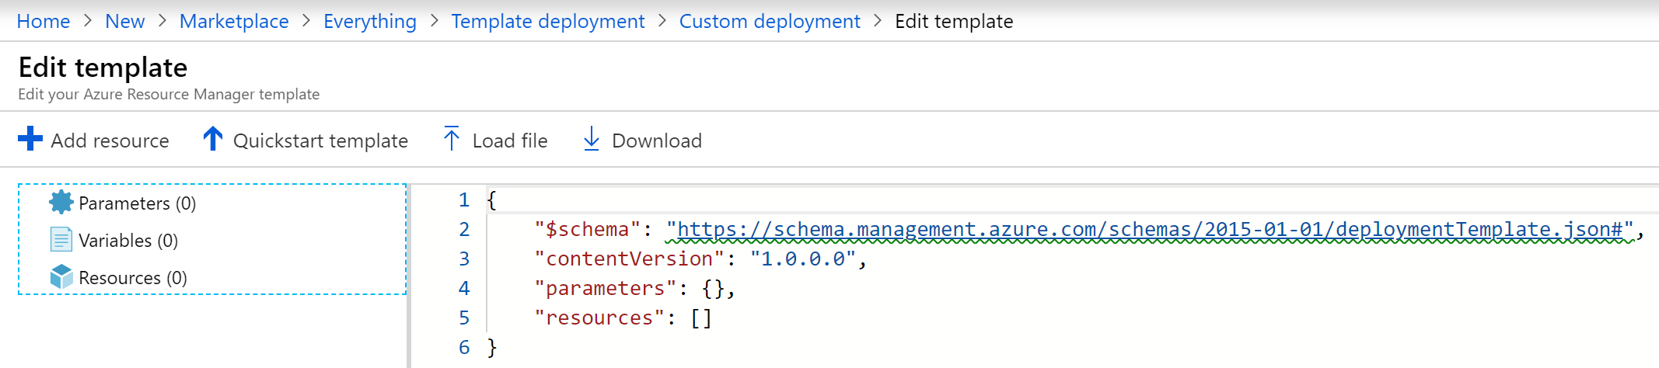
10. The Edit template blade should recognize the content of the JSON file, and showing the details in the JSON Outline on the left  
      
    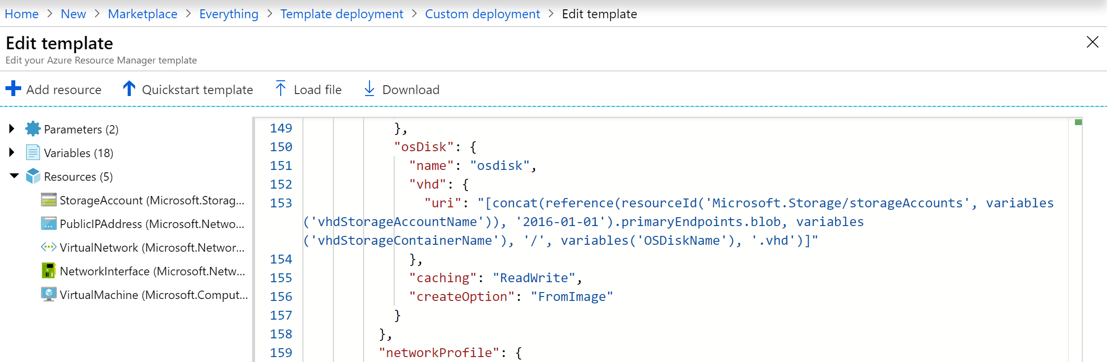
11. **Press** the **Save** button.
12. This **redirects** you back to the Custom deployment blade, from where you will **execute** the actual template deployment, filling in the required fields as follows:  
    **- Subscription: your Azure subscription  
    - Resource Group: Create New / [SUFFIX]-JumpVMRG  
    - Location: your closest by Azure Region  
    - Admin Username: labadmin** (this information is picked up from the ARM-template; although you could change this, we recommend you to not do so for consistency with the lab guide instructions and avoiding any errors during later deployment steps)  
    **- Admin Password:** [**L@BadminPa55w.rd**](mailto:L@BadminPa55w.rd)(this information is picked up from the ARM-template; although you could change this, we recommend you to not do so for consistency with the lab guide instructions and avoiding any errors during later deployment steps)  
    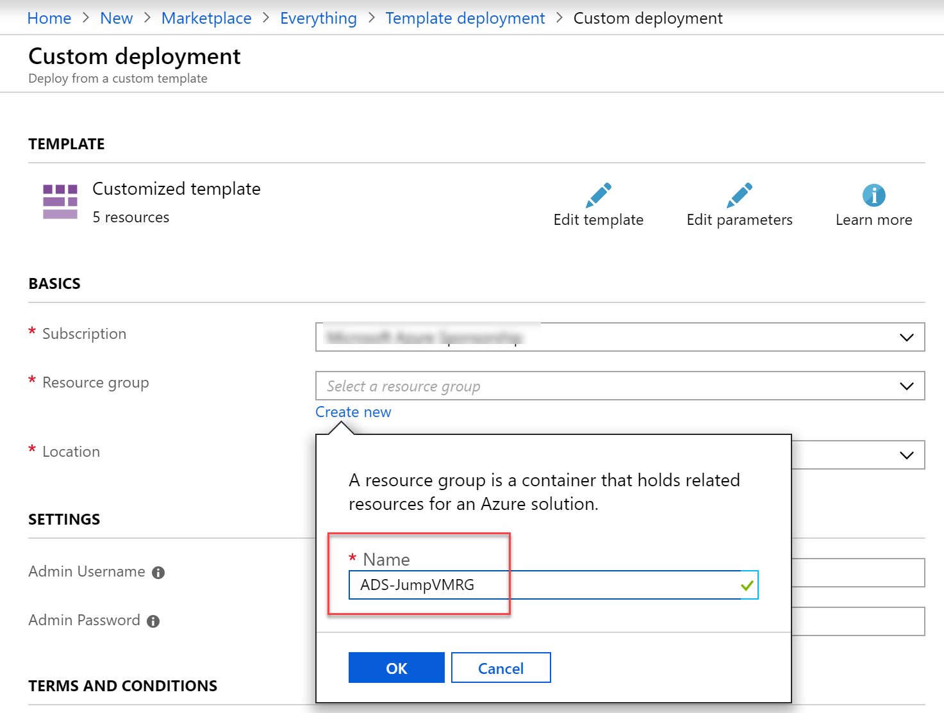
13. When all fields have been completed, scroll down in the blade. Under the terms and conditions section, **Check “I agree to the terms and conditions state above”**, and **press** the **Purchase** button.  
      
    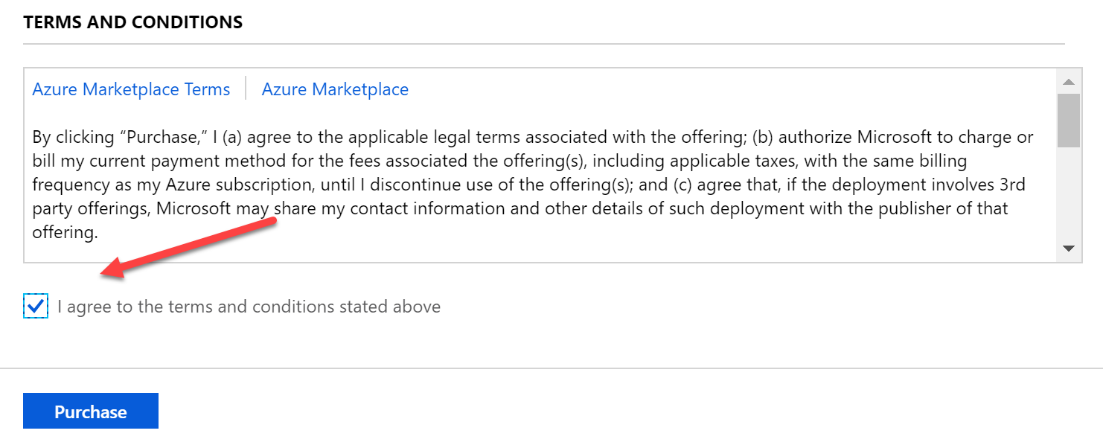
14. This sets off the actual Azure Resource deployment process. From the **notification area**, you can get update information about the deployment.  
      
    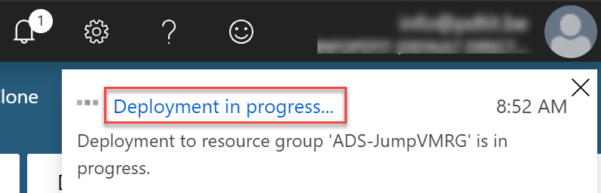
15. If you click the “…Deployment in progress…”, you will get redirected to the Microsoft template Overview blade, showing you the details of each Azure Resource getting deployed.  
      
    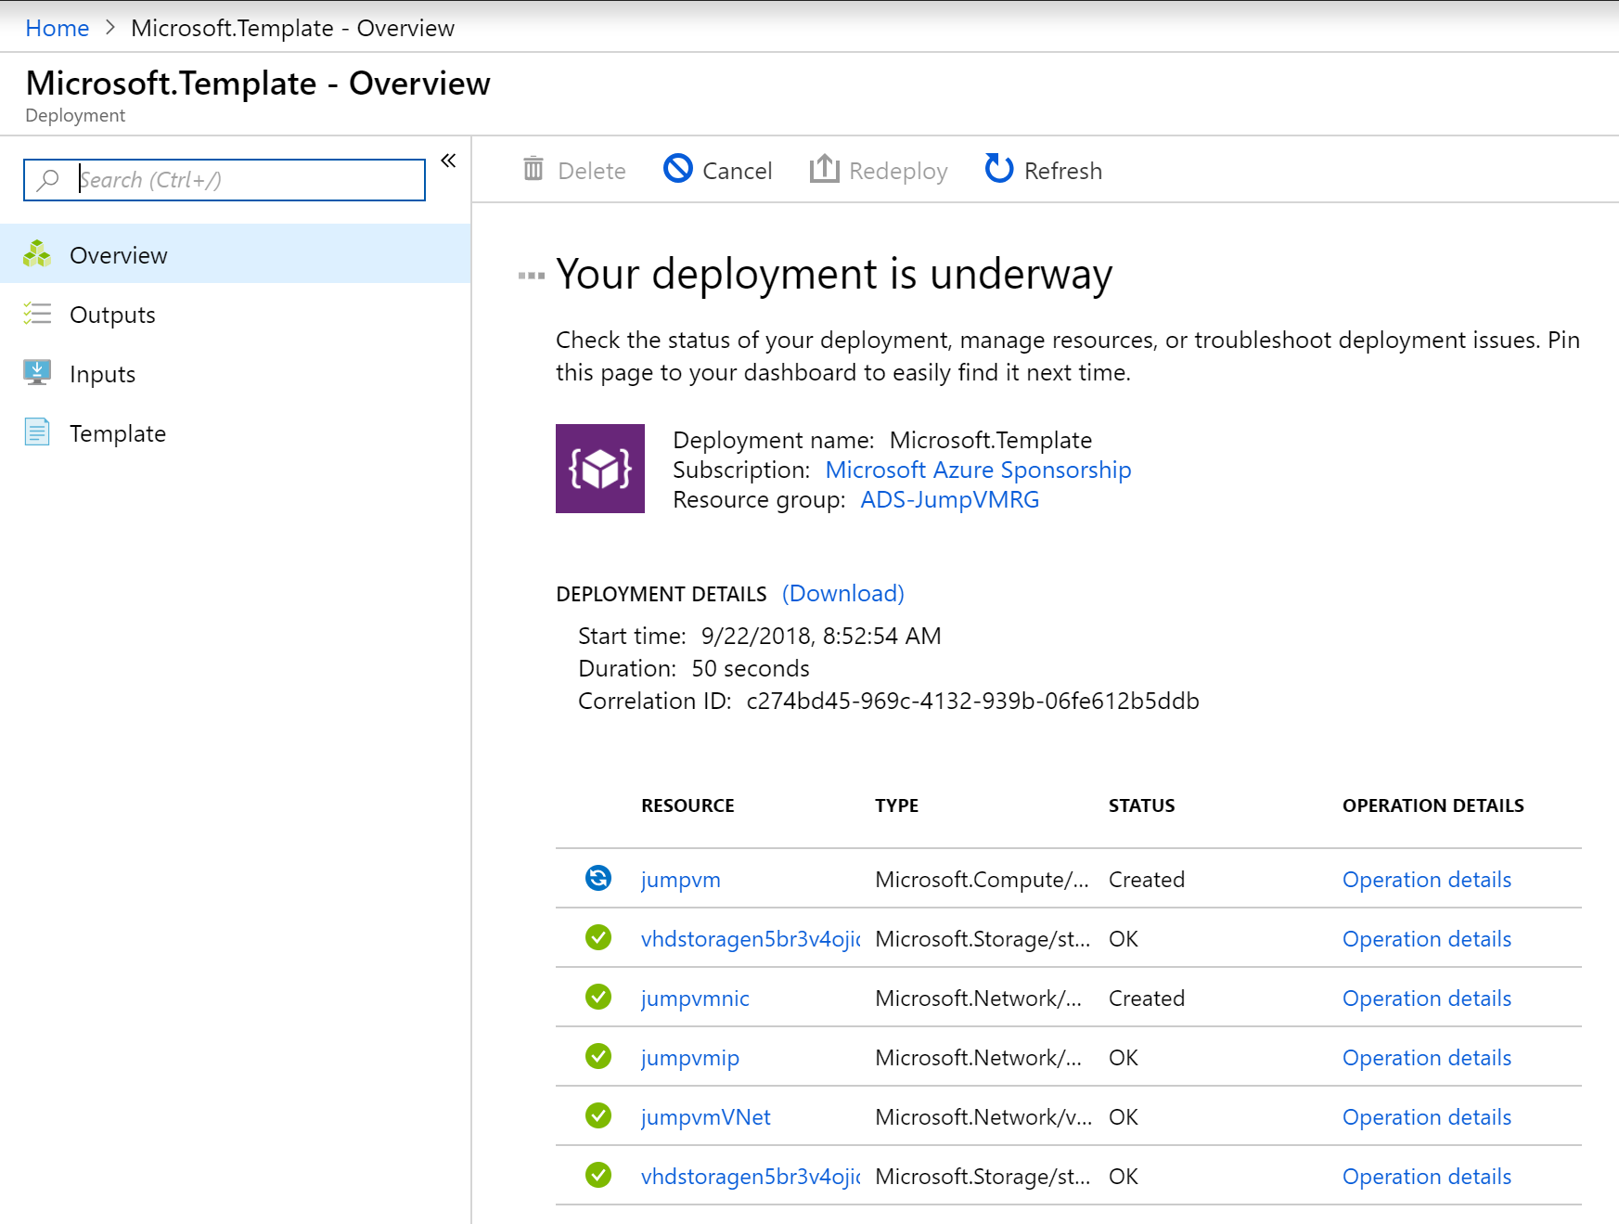
16. Wait for the deployment to complete successfully, which you can see from this detailed view, or from the notification area.  
      
    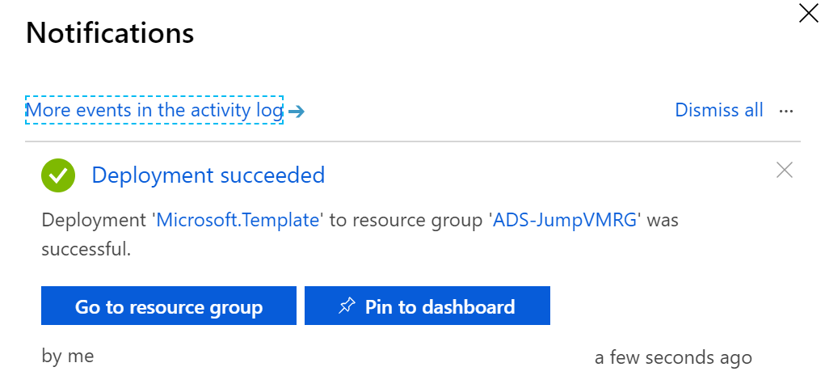
17. From the notification message, **click** “Go to resource group”. (If you already closed the notification message, from the Azure Portal navigation menu to the left, select Resource Groups).   
      
    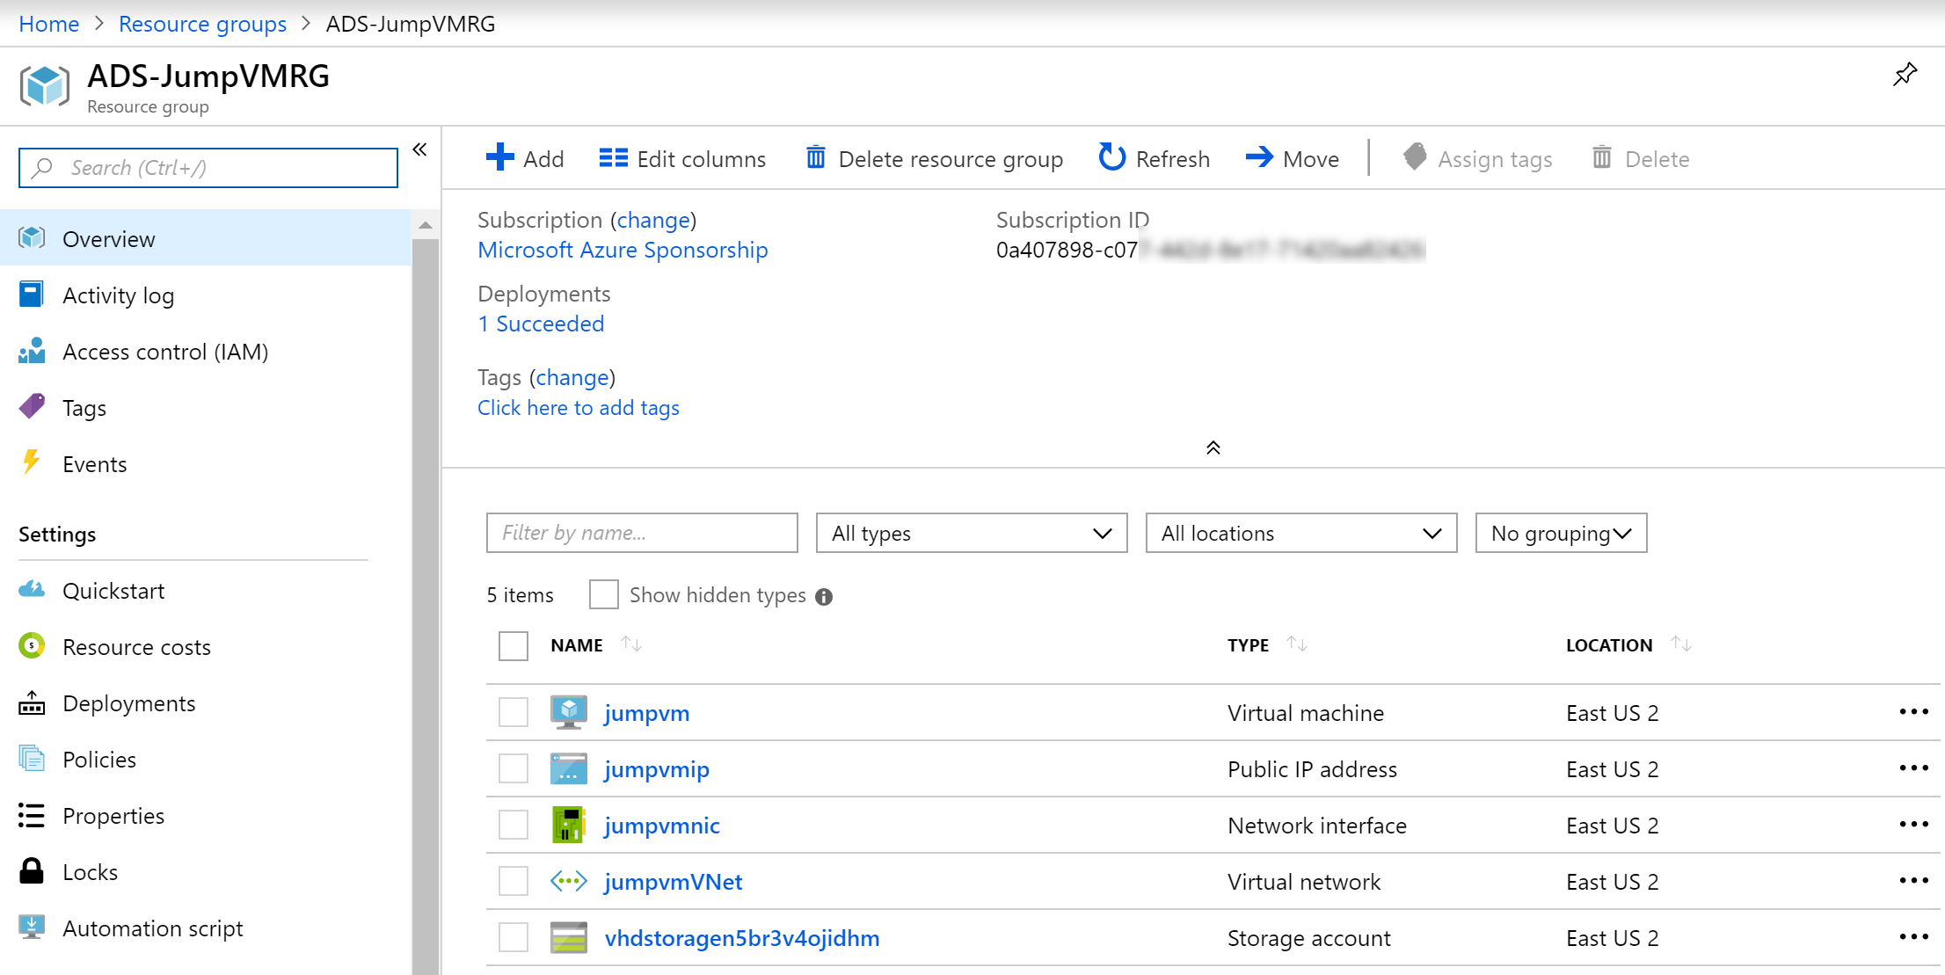
18. **Click** on the **jumpvm Azure Virtual Machine** resource. This redirects you to the detailed blade for the jumpvm resource. Here, **press** the **Connect** button.

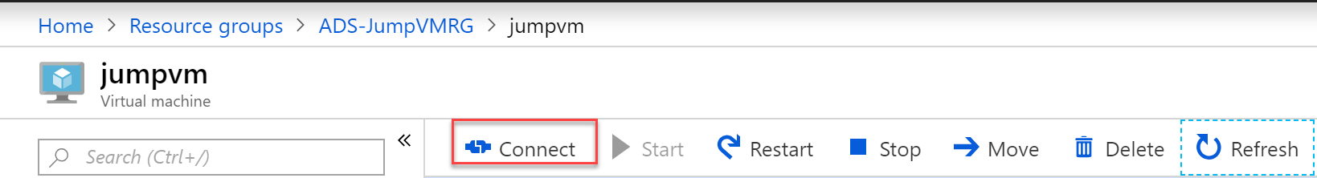

1. From the **Connect to Virtual machine** blade, notice the **public IP-address and port 3389**. This allows you to establish an RDP session to the Azure VM. Do this by **clicking** the **Download RDP file** button.  
     
   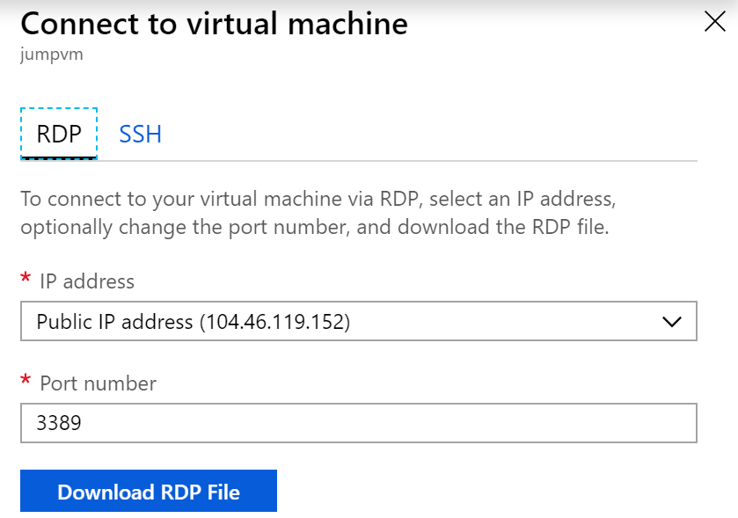
2. After the RDP connection file has been **downloaded**, **open** it up, which will launch the **Remote Desktop Connection** to that VM. In the appearing popup window, set the flag to “Don’t ask me again for connections to this computer.   
     
   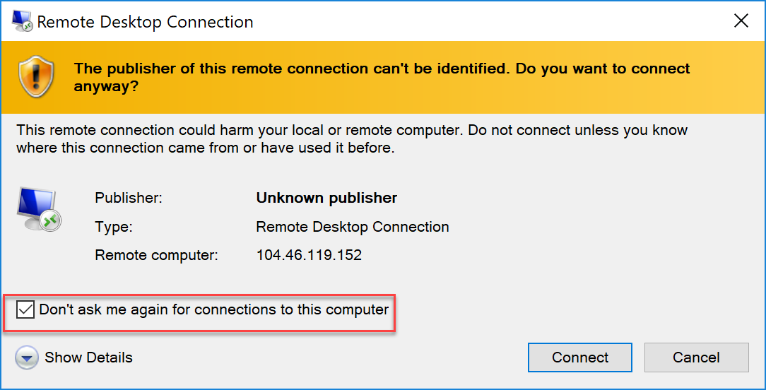
3. Press the **Connect** button; when it is asking for your **VM machine admin credentials** in the next step, provide the **VM administrator name (labadmin) as well as its password**.
4. Your Remote Desktop session to this Azure VM gets established.
5. **Close** the appearing “**Server Manager**”, you will access it again later.

This completes this task, in which you deployed a Windows 2016 lab-VM, by using Azure Resource Manager template-based deployment.

## Task 2: Deploying the baseline Virtual Machine environment using an ARM-template from within Visual Studio 2017/2019

In this task, you run the ARM-template which deploys the baseline Virtual Machine environment you need in the next lab. Deployment will be performed from within Visual Studio 2017.

1. From within the lab-JumpVM Virtual Machine RDP-session, open a browser session to <https://github.com/007FFFLearning/ADS-Containers/>, and **click** the **green Clone or Download button**.  
     
   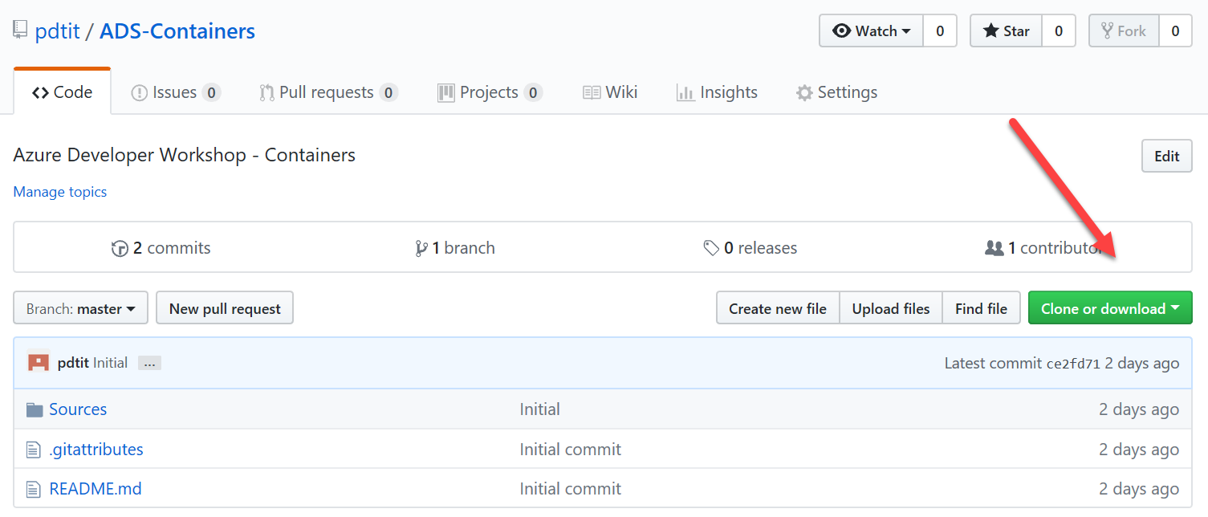
2. From the appearing popup, select **Download Zip.** This downloads the sources directory to the downloads folder on the lab-jumpVM.   
   **(note: if the Internet Explorer browser doesn’t allow downloads, go into its settings / internet options / and enable File Downloads and Font Downloads), and restart the browser.**
3. Once downloaded, **open** the downloads folder from within **File Explorer**, **right-click** the ADS-Containers.zip downloaded file, **choose Extract all…**   
   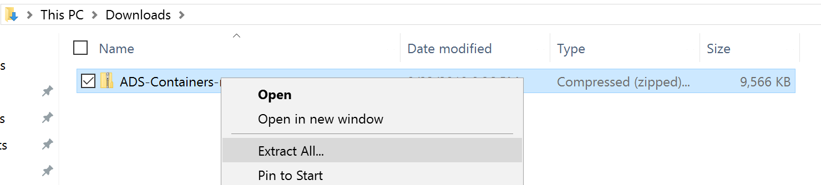
4. Extract the files to c:\ADS-Containers, or any other folder location of your choice.  
   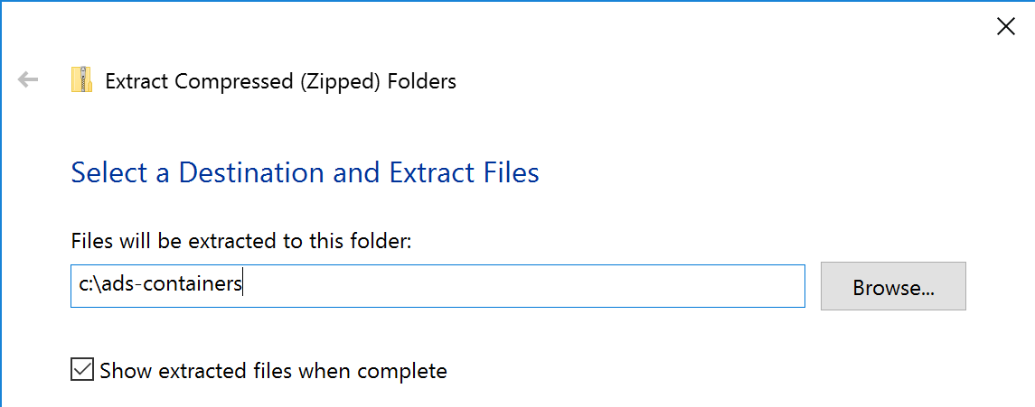
5. Once the extraction is completed successfully, **browse to the folder**. Within the folder, browse to **\ads-containers\ADS-Containers-master\Sources**. **Select** the compressed file “**ProductCat-VM-ARM-Deploy**”. **Right-click** this file, **choose Extract all**, and extract its content in a folder of choice, for example **c:\ProductCat-VM-ARM-Deploy**.
6. From the **lab-JumpVM Start Menu** or the shortcut on the desktop, **open Visual Studio 2017.** Since this is the first time you launch Visual Studio after a fresh install, you are greeted with the Visual Studio welcome message.   
   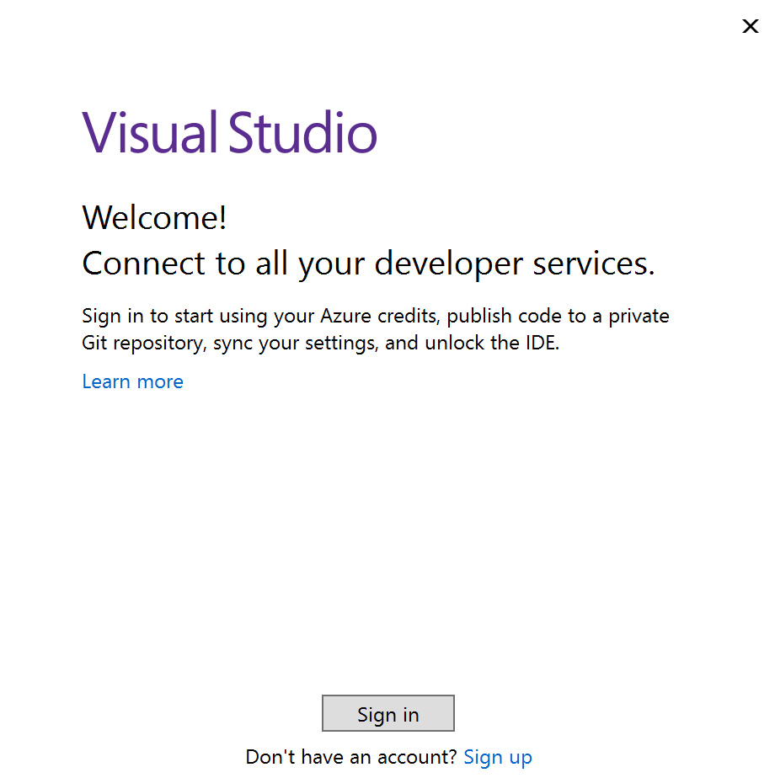
7. It asks you to sign in, so press that button. Here, authenticate with your **Azure subscription credentials.**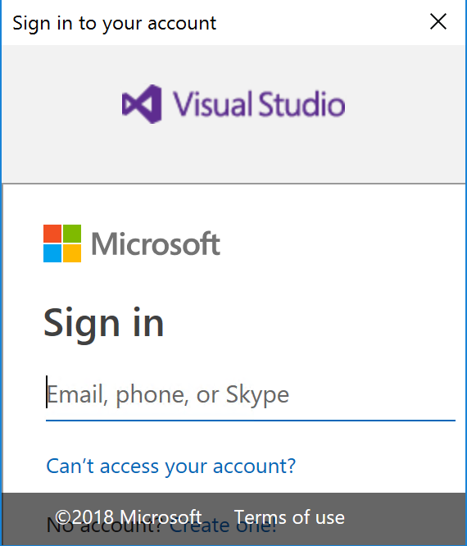
8. After successful authentication, you can choose a layout theme. Select a theme of choice, and wait until the Visual Studio environment completed loading.
9. From the Visual Studio menu, click File / Open / Project/Solution…  
     
   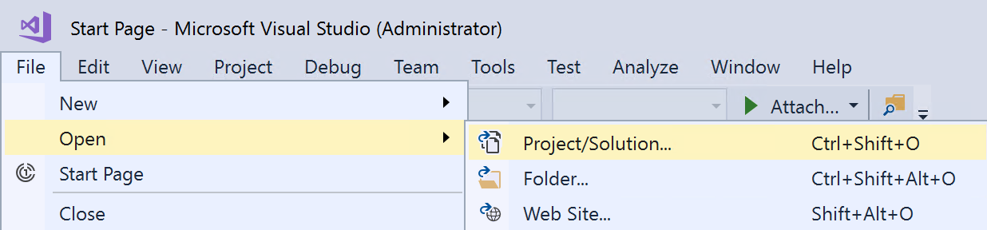
10. Browse to the folder where you extracted the “productCat-VM-ARM-Deploy” files. Click through the subfolders until you are at the folder showing **AzureResourceGroup44 Microsoft Visual Studio Project file type** (in our setup, this is c:\ProductCat-VM-ARM-deploy\ARM-Template-WebandSQL-finalversion)  
      
    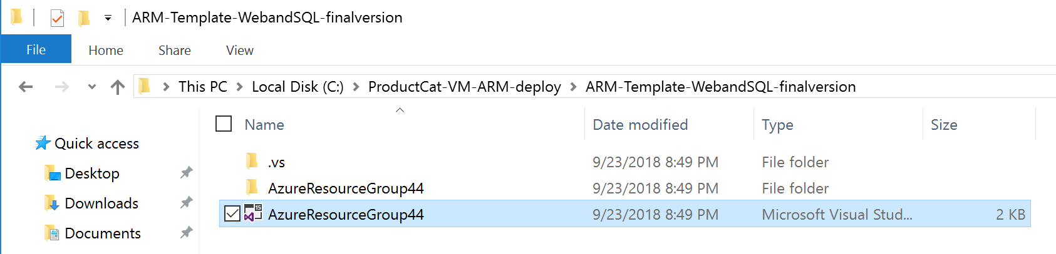
11. **Confirm** to open this project by pressing the **Open** button. This loads the project in Visual Studio.
12. Visual Studio will throw a security warning popup message; this is to warn you to only open Projects from trusted locations. **Press** the **Ok button** to continue.   
      
    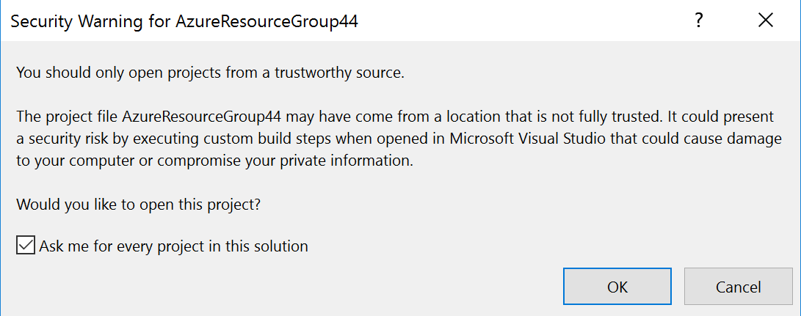
13. Once the project is opened in Visual Studio, you should have the Solution Explorer to the right of the screen, showing the actual deployment project folder and file structure.  
      
    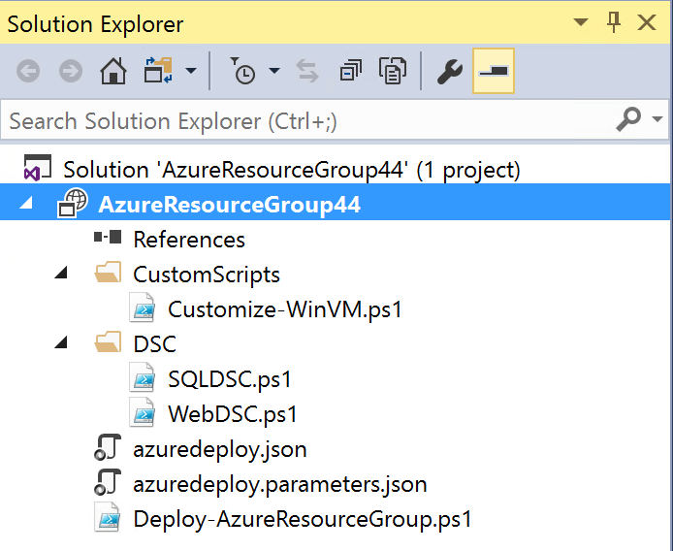
14. In short, these files are doing the following:

|  |  |
| --- | --- |
| **File** | **Purpose** |
| Azuredeploy.json | The actual ARM-template deployment file, which creates the different Azure Resources for both WebVM and SQLVM infrastructure. |
| Azuredeploy.parameters.json | The ARM-template parameters file |
| \CustomScripts\Customize-WinVM.ps1 | A PowerShell script, containing specific settings that get applied to both VMs using PowerShell |
| DSC\SQLDSC.ps1 | A PowerShell script that is used to customize the installation and configuration of SQL Server on the SQLVM - format disks - install SQL Server 2017 + Mgmt tools - download simplcommerce.bak from Azure Storage - run SQL database restore |
| DSC\WebDSC.ps1 | A PowerShell script that is used to customize the installation and configuration of IIS Web Server on the WebVM - install IIS core components + mgmt. tools - install .NET framework 4.5 - run silent install of the dotnetcore modules |
| Deploy-AzureResourceGroup.ps1 | A PowerShell script that is used by VS2017 to run the actual deployment of the ARM-template |
|  |  |

1. From within the Solution Explorer window, select the **AzureResourceGroup44** project, **right-click** it and from the context menu, select **Deployment / New…**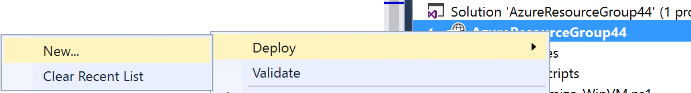
2. In the appearing “Deploy to Resource Group” popup, complete the following settings:

* Subscription: **Your Azure Subscription**
* Resource Group: **Create New / [SUFFIX]-VMs** – location = **closest by to your location**
* Deployment template: **azuredeploy.json**
* Template Parameters File: **azuredeploy.parameters.json**  
    
  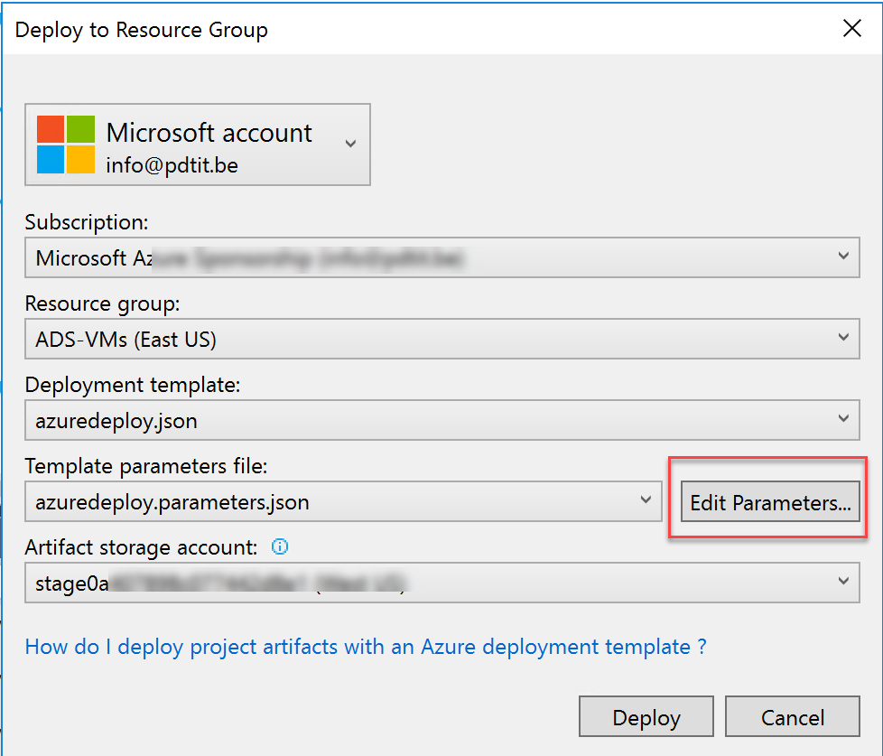

1. **Before pressing the Deploy** button, complete some additional deployment settings by **pressing the Edit Parameters button**:  
     
   Basically, the only required change here, is providing a new unique dns name for the **WebPublicIPDnsName** parameter.  
     
   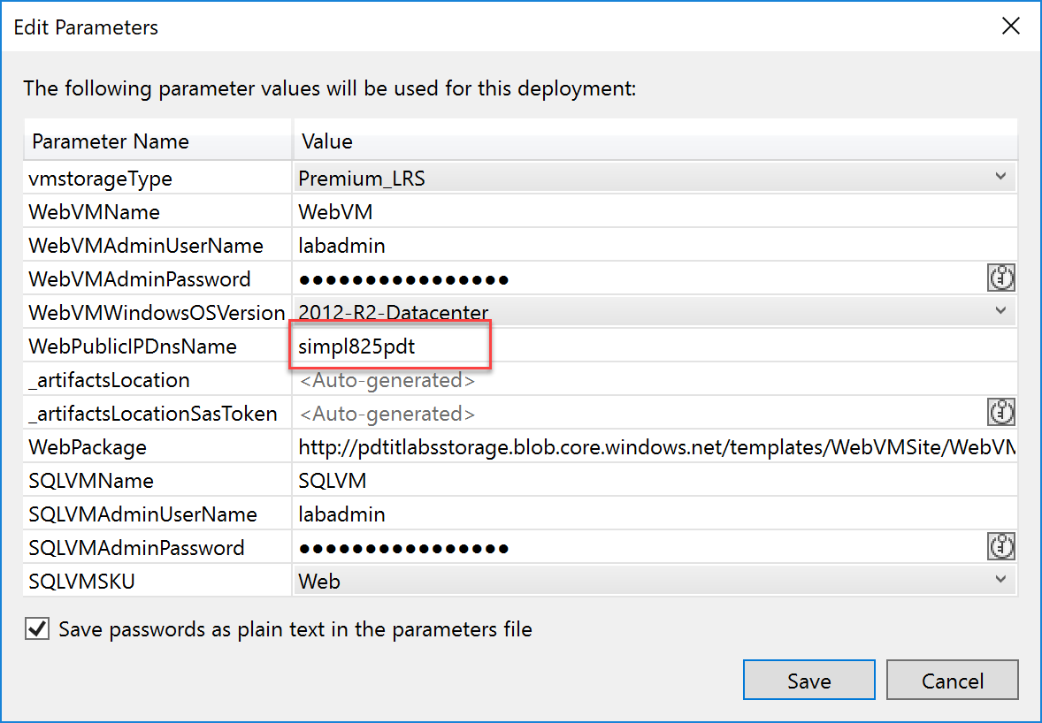

* WebVMName: WebVM
* WebVMAdminUserName: labadmin
* WebVMAdminPassword: [L@BadminPa55w.rd](mailto:L@BadminPa55w.rd) **(do not alter this password, as otherwise the customization script later on won’t work)**
* WebVMWindowsOSVersion: 2012-R2-Datacenter
* **WebPublicIPDnsName: [SUFFIX]containersDATE**
* SQLVMName: SQLVM
* SQLVMAdminUsername: labadmin
* SQLVM WebVMAdminPassword**:** [**L@BadminPa55w.rd**](mailto:L@BadminPa55w.rd) **(do not alter this password, as otherwise the customization script later on won’t work)**

1. **Check** the “Save passwords as plain text in the parameters file”. (Note: This is ok in this lab environment, but not recommended in production deployments. If this option is not checked, you will get a PowerShell window appearing, asking you for this administrator password there).
2. Once all settings have been completed in the Parameters popup window, click **Save**. You are redirected to the “Deploy to Resource Group” window. Start the actual deployment by pressing the **Deploy** button.  
     
   
3. The Azure Resources deployment kicks off, which can be followed from the Visual Studio **Output** window. (**For your info, this deployment takes about 15-20min might be a good time for a break 😊).**  
     
   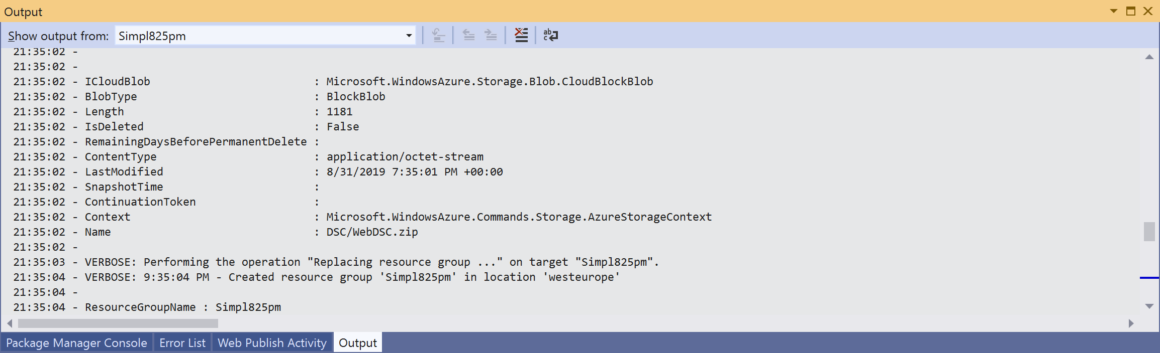  
     
   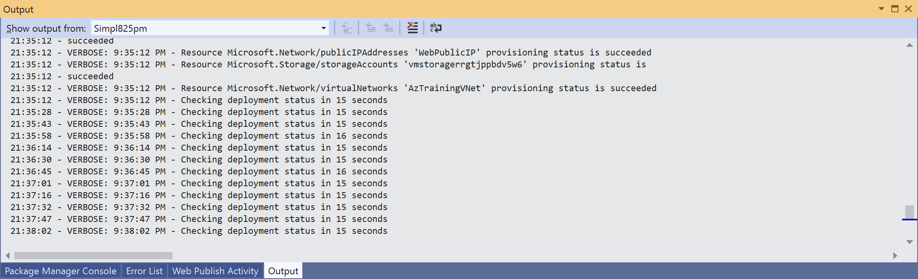
4. While the deployment from Visual Studio is still running, open your **internet browser**, **connect** to <http://portal.azure.com>, **authenticate** with your Azure subscription credentials. **Go to Resource Groups, open the [SUFFIX]containersDATE Resource Group**. Here, you can see the different resources getting created.  
     
   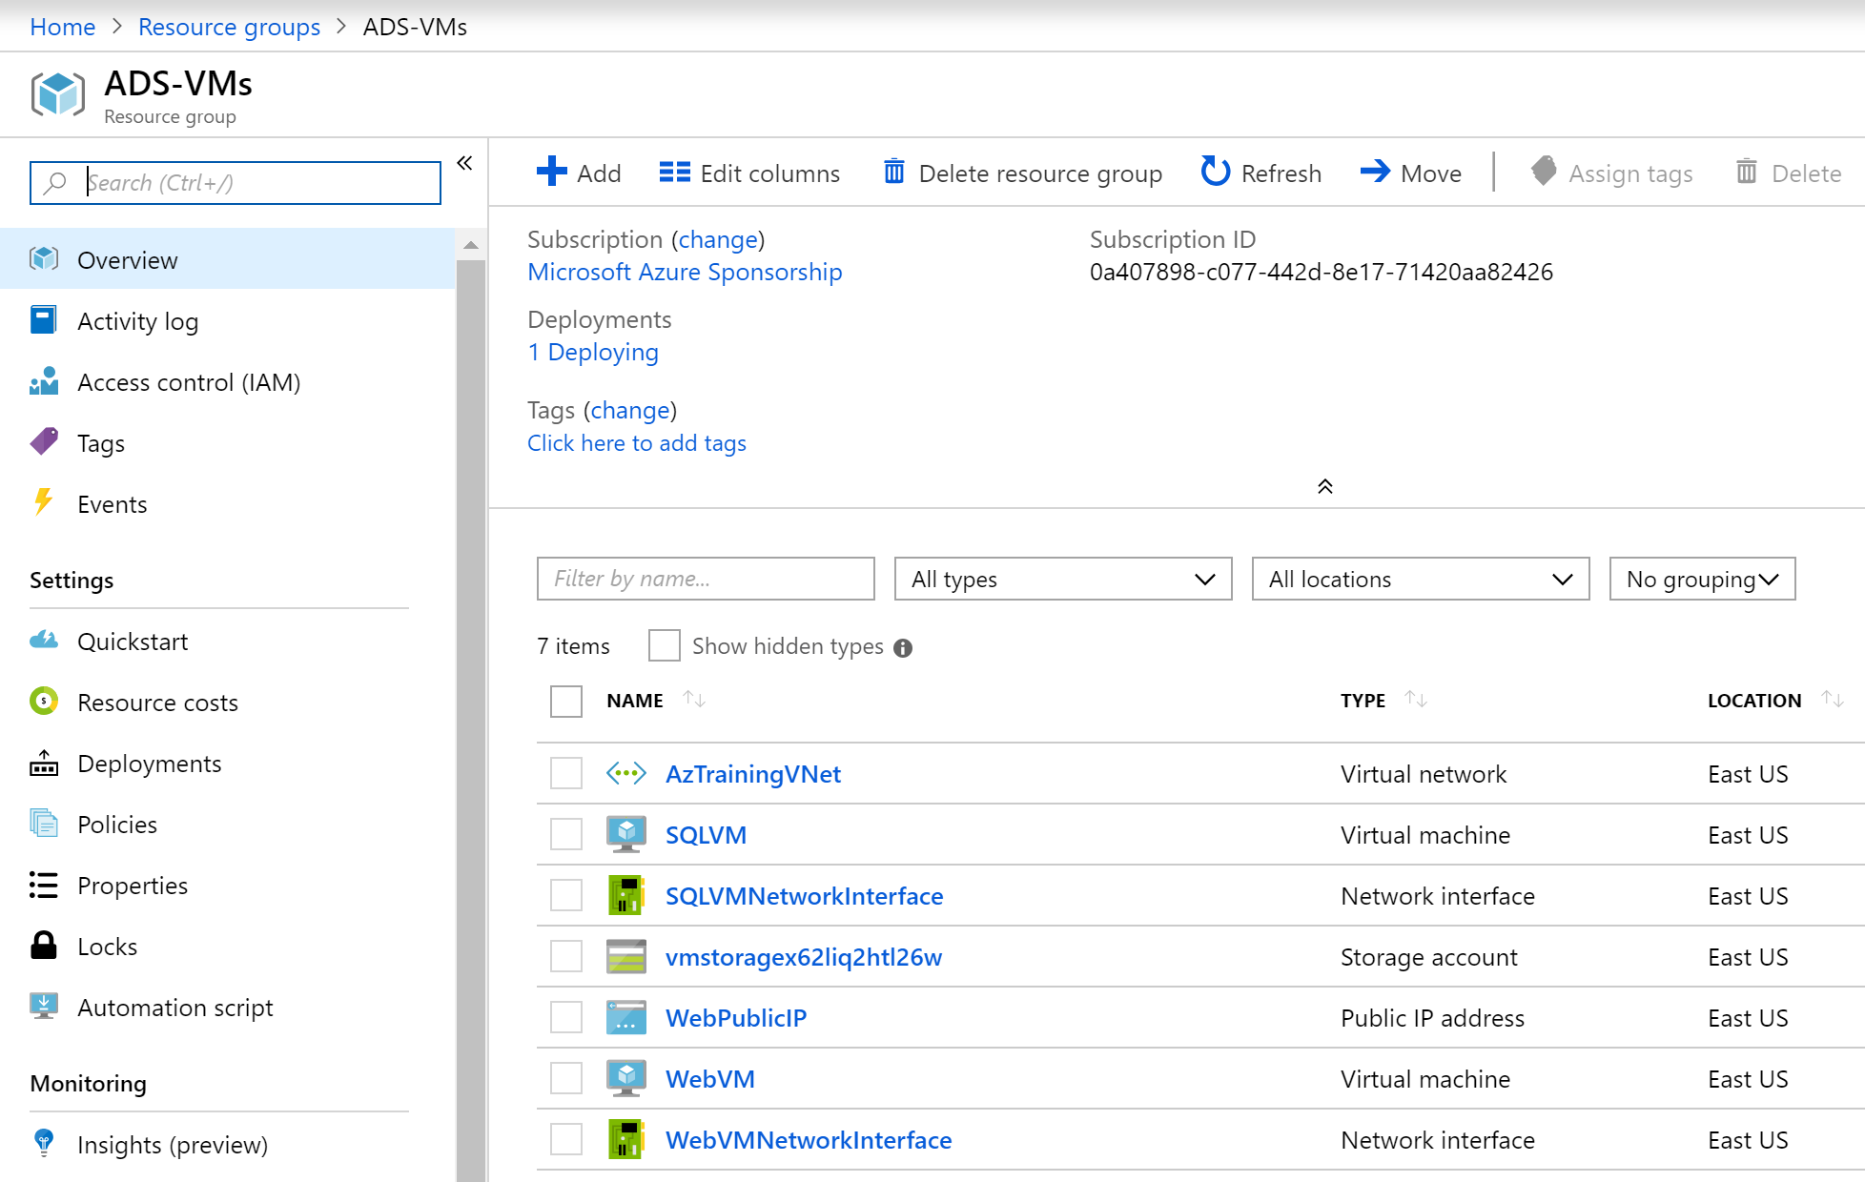
5. From the **Resource Group** blade, **Settings** section, click **Deployments.**
6. This **shows** the actual running deployment task.
7. **Click the deployment name <e.g. azuredeploy-0831-1935>,** which shows you more details about the actual deployment process, including the already deployed resources.  
     
   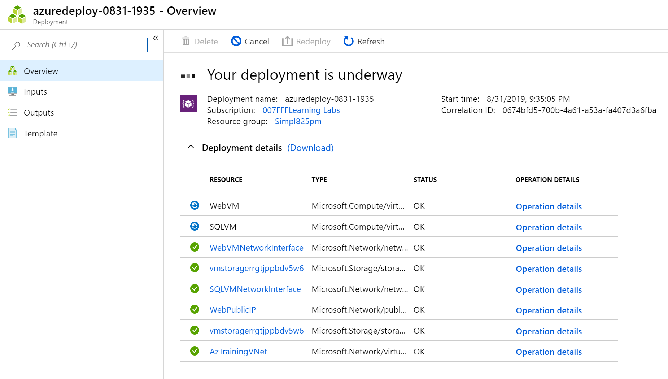
8. **Wait for the deployment to complete successfully**. This is noticeable from within the Visual Studio Output window, or from within the Azure Portal deployment blade you were in before.  
     
   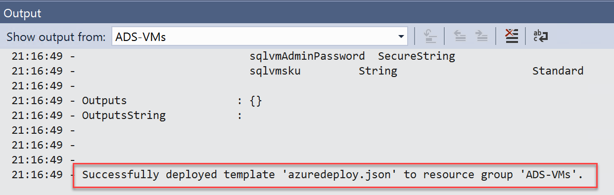  
     
   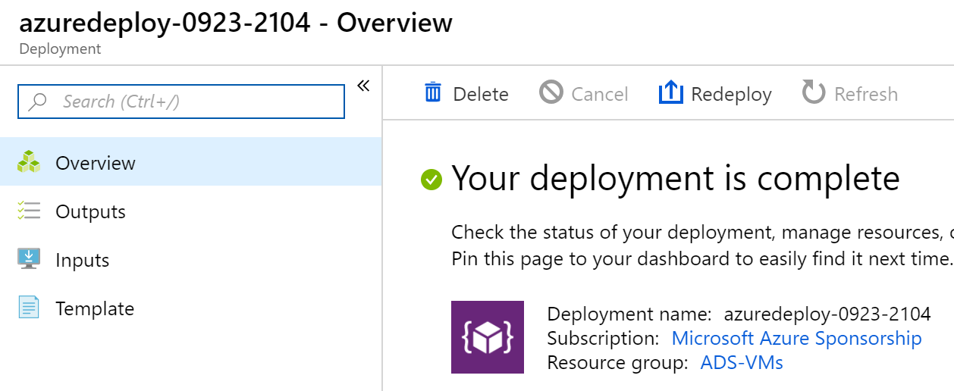
9. **Close Visual Studio** without saving changes to the project.

To verify all went fine during the deployment of the Azure Resources, as well as the customization and configuration using PowerShell Desired State Configuration, log on to the WebVM to validate the IIS and SQL install ran as expected.

1. From within the **Azure Portal**, go to **Resource Groups**, and select the Resource Group where **you deployed the VMs**. In here, **select the WebVM** Virtual Machine by **clicking** on it. This **opens the WebVM detailed blade**.   
     
   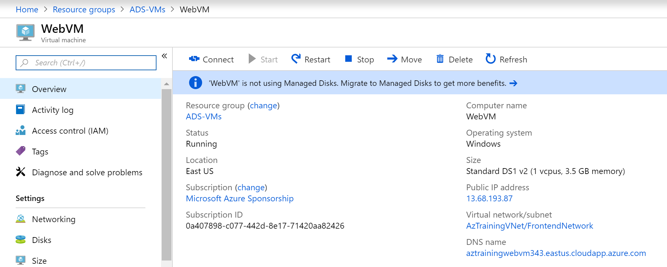
2. Similar to what you did with the lab-JumpVM, press the **Connect** button, to open the Remote Dekstop session to this WebVM Virtual Machine.   
     
   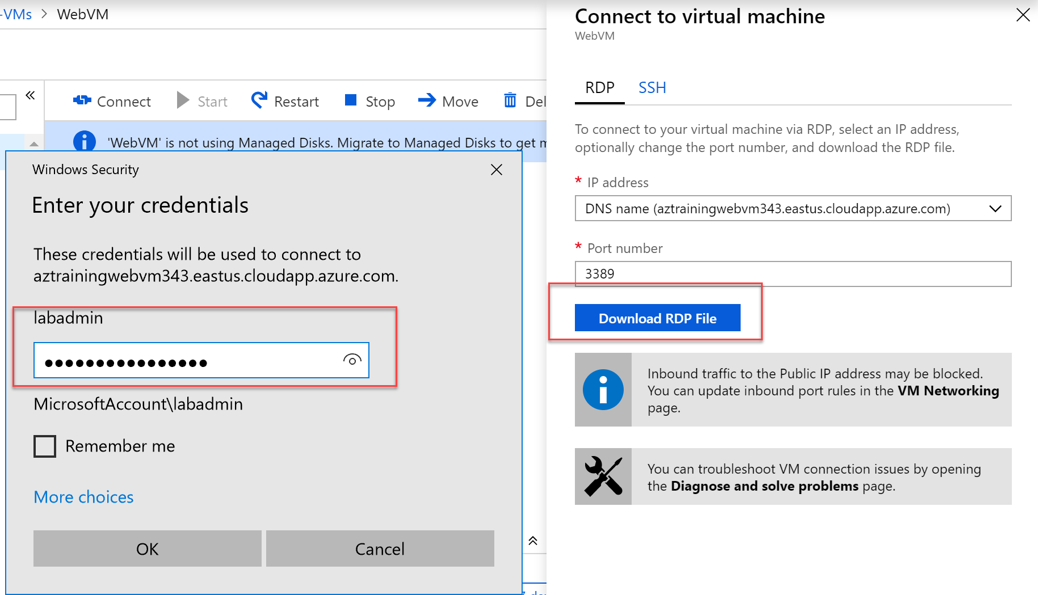
3. Here, log on with the credentials from the ARM template (labadmin / [L@BadminPa55w.rd](mailto:L@BadminPa55w.rd)) unless you changed those before the deployment.
4. From within the WebVM RDP-session’s Start Menu, search for “**IIS**”, which resolves **Internet Information Server Manager**.  
     
   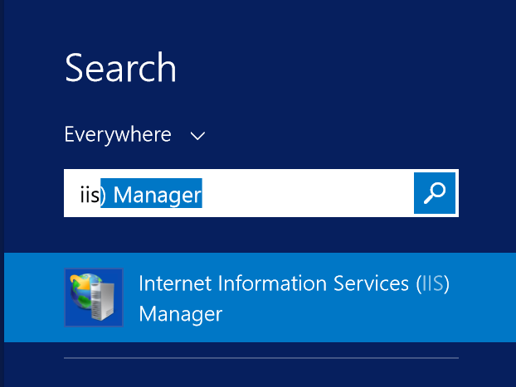
5. **Launch** Internet Information Services Manager.  
     
   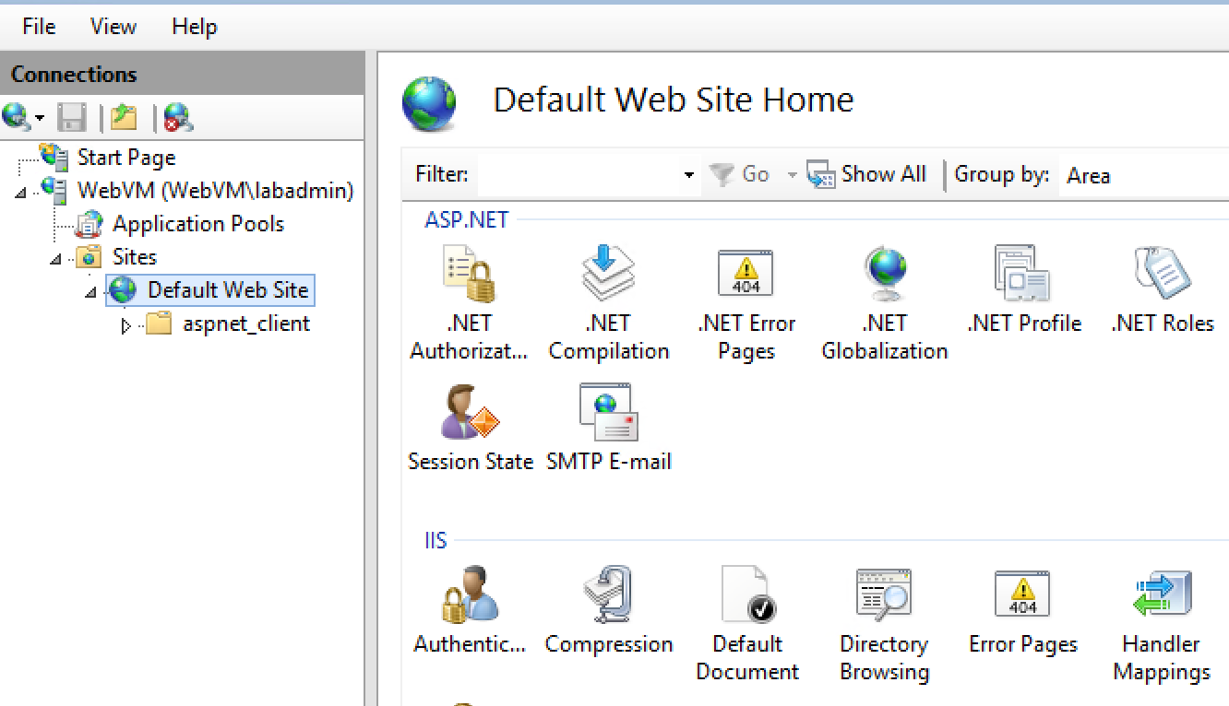
6. **This deployment has a Default Web Site** configured.
7. **From within the WebVM**, open an internet browser session, and connect to <http://localhost>, which should open the default IIS welcome web page  
     
   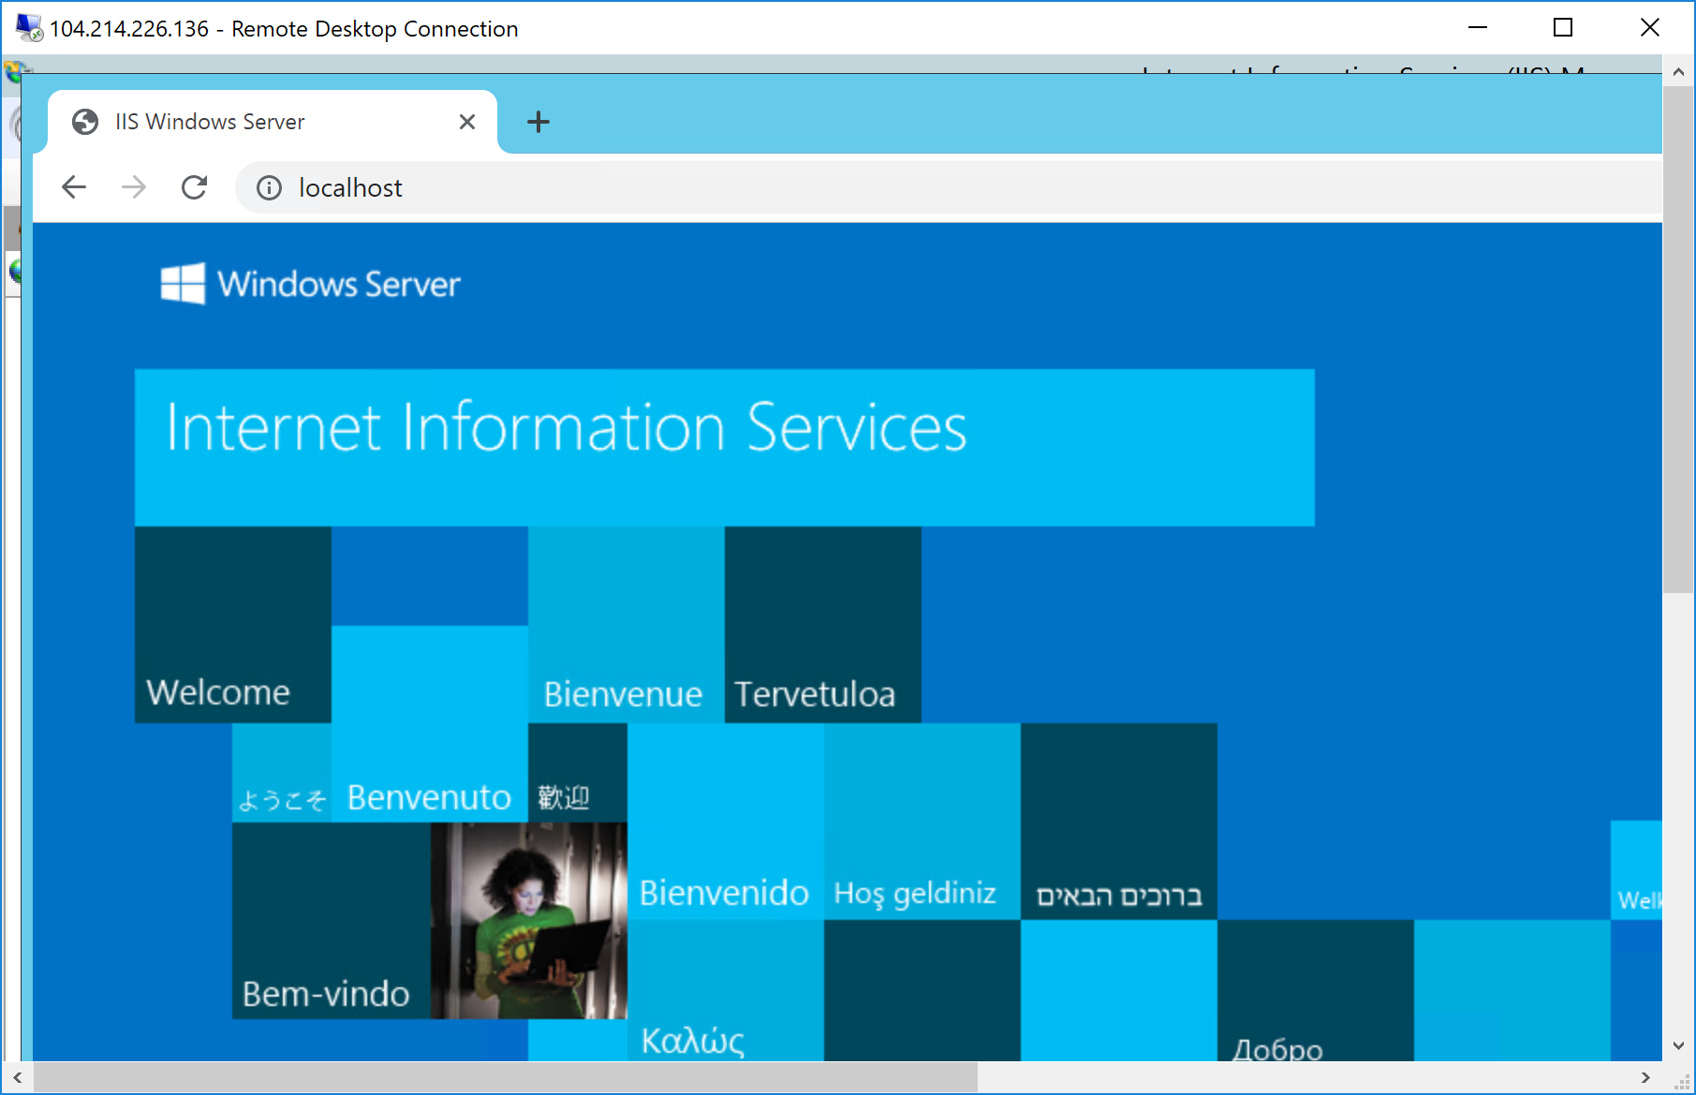
8. This confirms IIS is working fine. (Note we don’t have the actual e-commerce sample application deployed yet at this time)

Close the internet browser session on the WebVM.

1. **Still from within the WebVM RDP session**, start a new RDP session to the SQLVM (this needs to happen from within the WebVM, as the SQLVM has no public IP-address attached to its NIC),   
     
   by clicking the start button, and typing “**mstsc**”; this finds the Microsoft Remote Desktop Connection. **Launch it.**   
     
   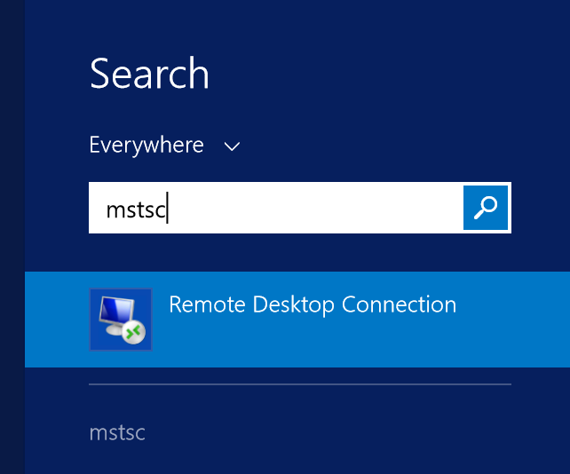
2. Enter “**sqlvm**” as computer name; **next**, press the **Connect** button.   
     
   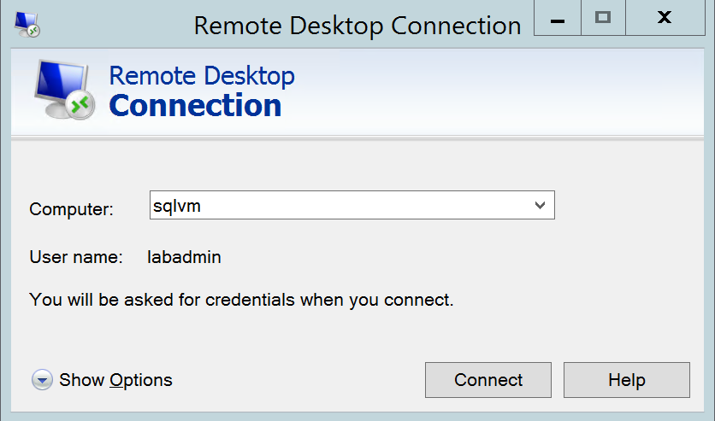
3. Provide the following credentials to authenticate:  
     
   user = labadmin  
   password = [L@BadminPa55w.rd](mailto:L@BadminPa55w.rd)  
     
   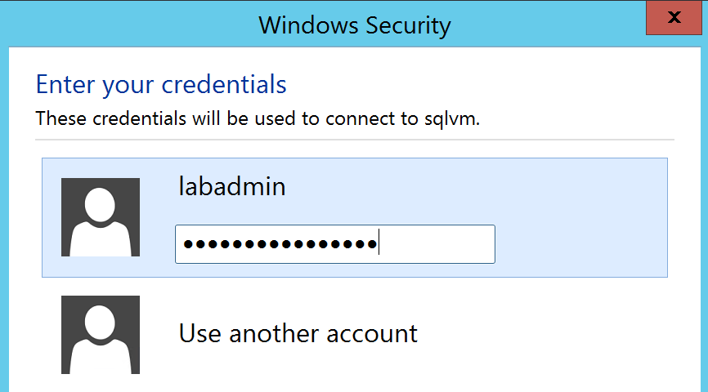
4. And **press OK** to continue.
5. When prompted with “**the identity cannot be verified”** error, **select “don’t ask me again for connections to this computer”**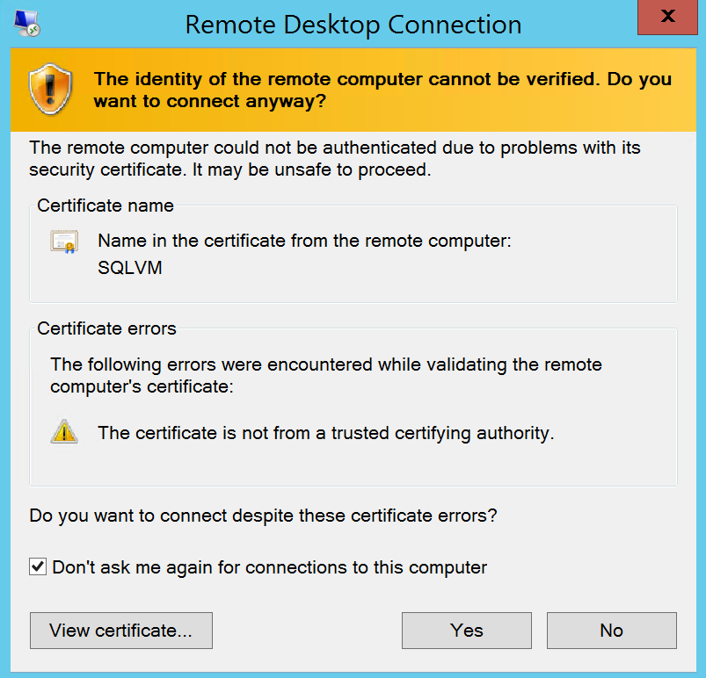
6. **Click Yes** to open the RDP session. Wait for the desktop of the SQLVM to load completely.
7. From the Start Menu of the SQLVM, search for “Management Studio 17”, which will resolve a list of keywords and applications. Here, select **Microsoft** **SQL Server Management Studio 2017**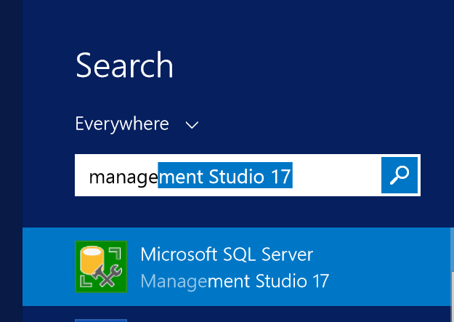
8. From SQL Management Studio, the “**Connect to Server**” popup opens. Provide the following information:  
     
   - Server Type: **Database Engine**- Server Name: **SQLVM**- Authentication: **SQL Server Authentication**  
   - Login: **sa**  
   - Password: [L@BadminPa55w.rd](mailto:L@BadminPa55w.rd)  
   - Set to **Remember Password**  
     
   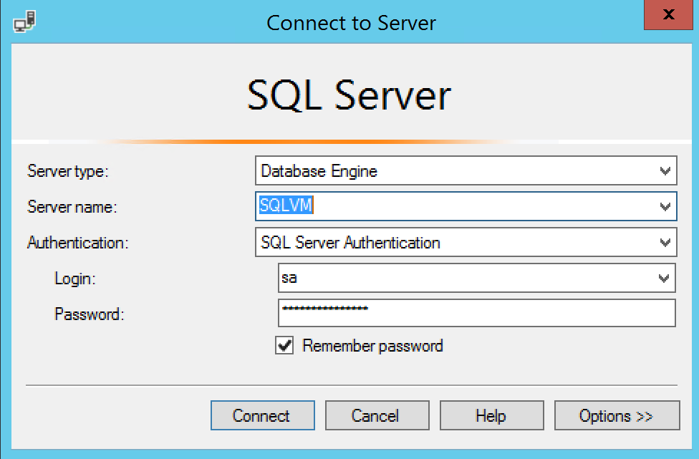
9. Press **Connect** to open the SQL Server connection
10. Validate the **SimplCommerce** database object is available under the Databases section of the server.  
      
    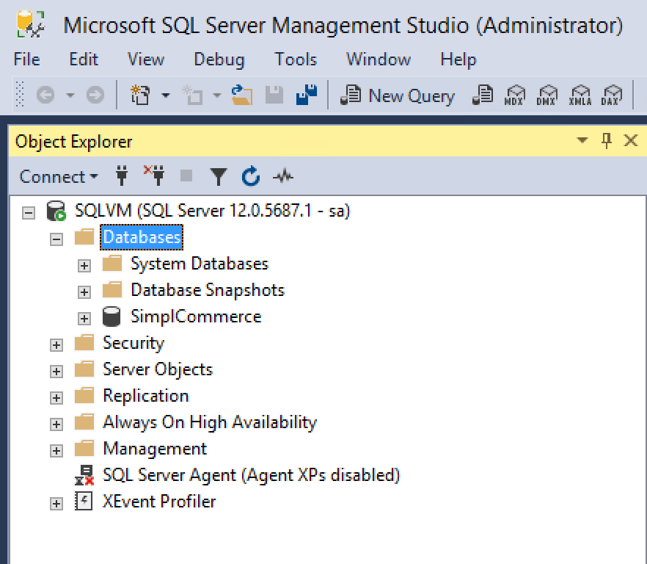
11. Open the SimplCommerce database, by clicking the “+” in front of the name; browse to **Tables** and press the “+” again here. This opens a list of all tables within this database. Here, browse to **dbo.catalog_product** and **select it**.
12. Next, **rightclick** on this table, to open the context menu. Here, **select “Edit top 200 Rows”**  
      
    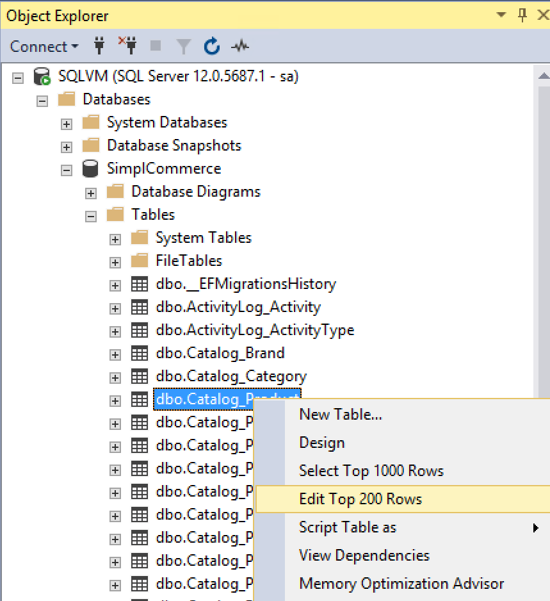
13. This shows a list of products in our sample e-commerce application.  
      
    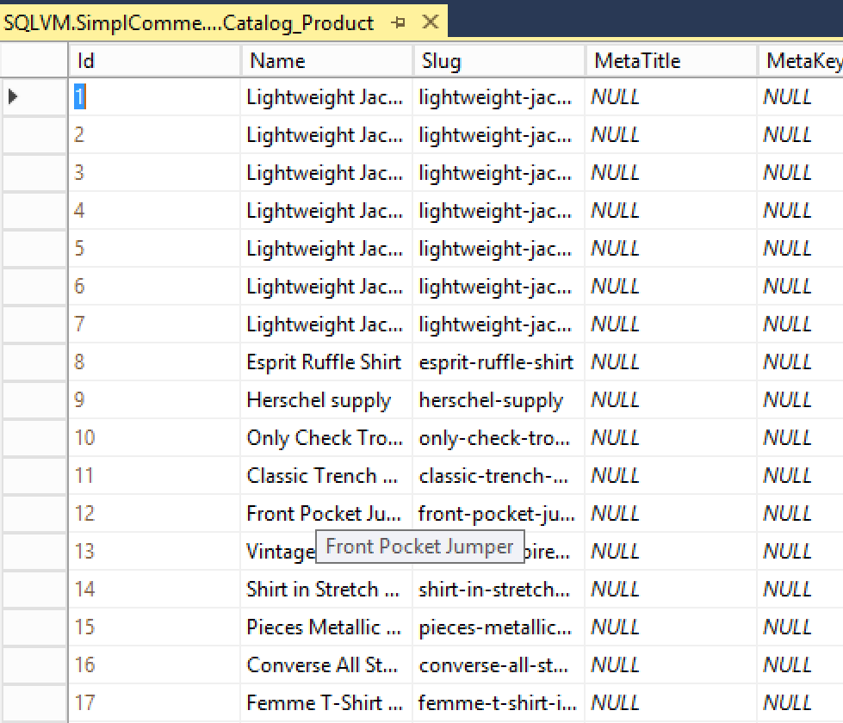
14. This confirms the deployment of the SQL Server VM was successful.

This completes the task.

# Summary

In this lab, you started with deploying an ARM-template from within the Azure Portal, deploying a lab-JumpVM Virtual Machine in Azure.

In the next task, you learned how to deploy a more complex Azure environment, again using an ARM-template, where deployment was executed from within Visual Studio 2017/2019, using ARM templates to deploy Azure resources, as well as relying on Azure VM PowerShell DSC and Custom Script Extensions to finetune the configuration of the WebVM and SQLVM virtual machines.